Fully Automated Pulse Sensing Tool

Undergraduate Project: Midterm Report

Name: Tyler Eck

Student ID: 410821337

Advisor: Shi-Jim Yen 顏士淨

**Introduction**

In this evolving technological era, automation is slowly finding its way into our daily lives. With its convenience and consistency, automation allows for users to hand over control to machines to do repetitive and trivial tasks. The most popular example of this is smart home devices that allow homeowners to automate things in their house such as lights for energy conservation and the door lock for security. As popularity and demand grow, I believe the next logical step is to implement automation in a more important role such as for medical purposes. Therefore, in this project, I propose a fully automated pulse sensing tool that will allow for a user to measure their pulse with ease. With a simple push of a button, a special camera will detect where the user’s pulse should be measured and move the pulse sensor automatically to that location on the wrist. As a result, the pulse will be measured accurately and the information can be sent remotely to any location, which would ideally be a doctor for analysis.

**Research Motivation**

The motivation for this project originated as a result of people being unable to go for frequent doctor visits due to living in remote areas. Small villages, especially in the east of Taiwan, lack doctors and special experts that are needed due to high numbers of elderly population living in those areas. Because of this, a lot of people need to travel far distances just to get a routine check-up. The proposed tool allows for convenience as the goal is to make it accessible for people to send their information remotely to the doctor for examination. Another advantage of this tool will allow doctors to track progress of the electrocardiogram (ECG) pulse reports to detect problems in the patient. The ease of access for both the doctors and the patients despite proximity problems allows for this tool to potentially have a high demand and make a significant impact on how people see the doctor.

**Project Plan**

The project’s goal is to make an automated system that remotely transmits data. It will need both the necessary equipment (hardware) to move motors and measure the pulse and the necessary software for detection of the wrist location and the transmission of data.

1. **Hardware**

The three main hardware components that I will need are the stepper motors to move the sensor, the camera as a digital input for detection, and the pulse sensor to measure the pulse. Fortunately, I am provided with a Creality CR10s 3D printer that has all the necessary motors with its stop switches connected in an X, Y, Z plane shown below in Figure 1.

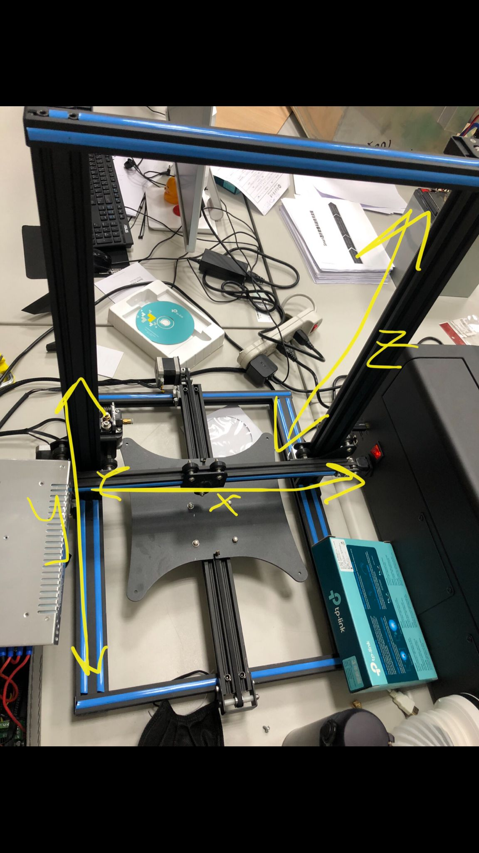

**Figure 1: 3D printer with dimensions**

The repurposing of this 3D printer requires a reprogramming of the stepper motors that are connected to the motherboard. The motherboard, which is housed separately with the battery and the screen, is an Arduino2560 microcontroller and can therefore be controlled using the Arduino IDE (the motherboard with the stepper motor connections is labelled in Figure 2). After the reprogramming is done, the motors should move in accordance with the X, Y, and Z Cartesian plane.

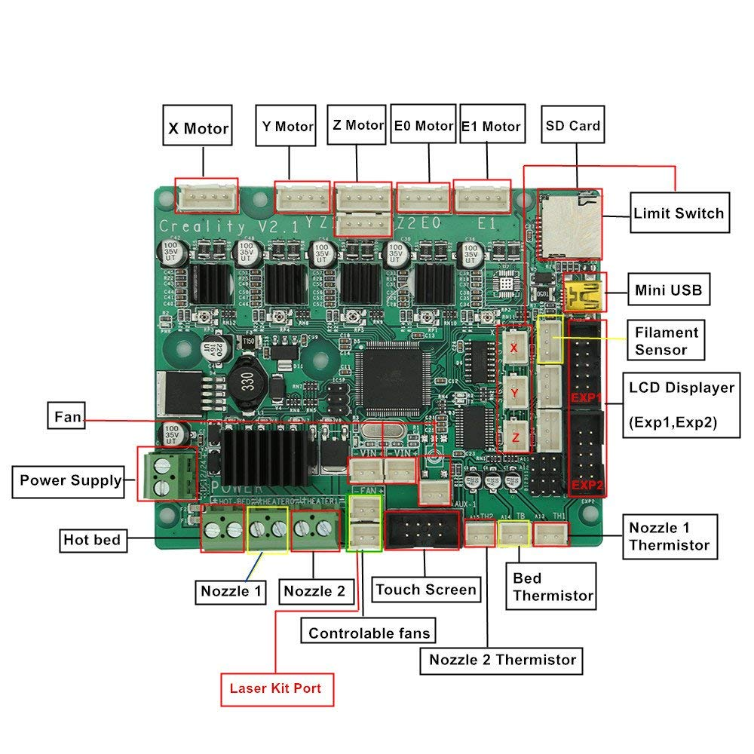

**Figure 2: Creality V2.1 Motherboard**

The pulse sensor and camera are both standard devices with no specific type for this project. However, the camera and the sensor need to be mounted together for accurate detection and movement. Therefore, a 3D printed plastic connection will be designed and printed to accommodate both the sensor and the camera together.

Lastly, the simple abstract flow of the program will run as shown below in Figure 3. The camera feed/picture will be the input to the detection algorithm. The detection algorithm will detect the pulse point and output the necessary x, y, and z values to use as inputs to our motor function. Lastly, the motor function will accept these inputs and move to the desired destination for the pulse information to be recorded and uploaded.

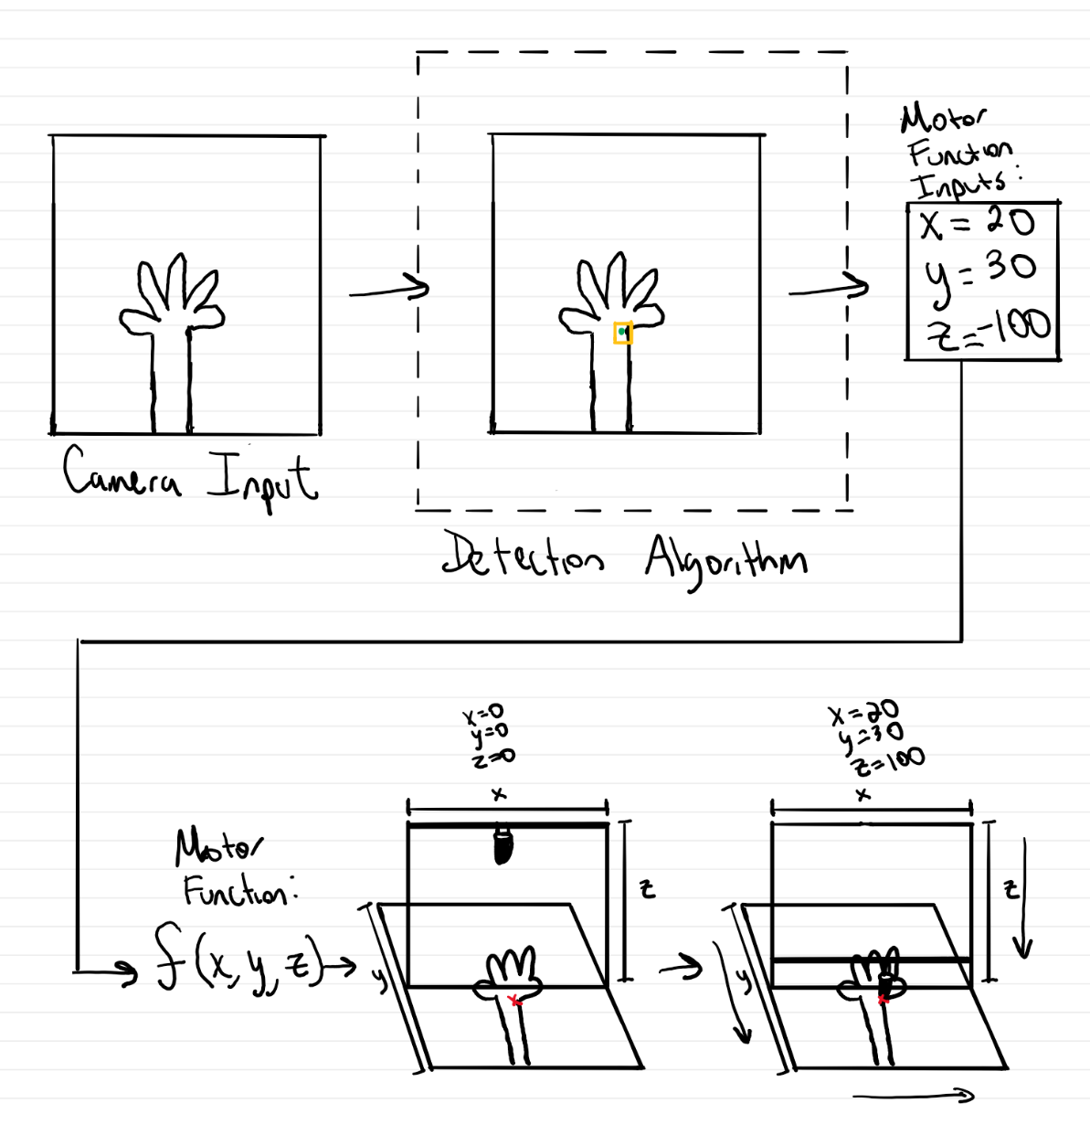

**Figure 3: Fully Automated Pulse Sensing Tool Abstract Model**

1. **Detection Method**

There are multiple detection methods that can be applied to detect the pulse point in a person’s wrist. I don’t believe I will train the model, but I will use a preexisting trained model for detection. Papers such as “Accurate targeting in robot-assisted TCM pulse diagnosis using adaptive sensor fusion” (Luo, Ouyang, et al.) and “Pulse Localization Networks with Infrared Camera” (Yang, Meng, et al.) will be used as a framework of comparison as to how to implement it. The latter method uses an infrared camera which allows for even a more accurate result. However, at this moment I have not yet decided on what method to use. A final decision will be based on both my advisor’s recommendation and the apparatus that is available to me. Nevertheless, it will be implemented to detect the pulse point and there will need to be a function in place to detect at what x, y, and z location the pulse sensor must be moved to.

1. **Cloud**

Lastly, after the pulse data is collected, it will need to be uploaded to cloud-based database. For the purpose of the project, I can either use Supabase or Firebase to upload the EKG information. Regardless of which I use, using a cloud-based database allows for ease of access to any doctor anywhere in Taiwan.

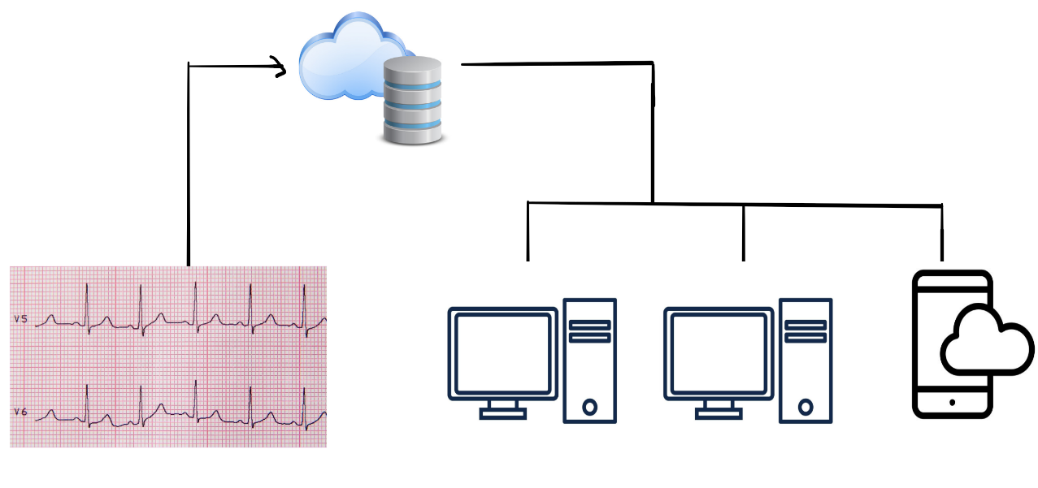

**Progress**

Most of the time was spent on research and design this semester. As shown above, the plan is still in its primary stages and needs much work. However, the one thing that has been completed is the function to move the motors freely. By researching the different motherboards and searching through the source code of the Marlin firmware, the specific pins that the motors were connected to were identified. With this, I successfully created a function to move the stepper motors freely. This integral part of the project is a small contribution; however, most of the research and planning are done and all that is left to do is to implement. Although I am the sole group member, I will be putting in time throughout this winter break and throughout next semester to implement this fully automated pulse sensing tool.